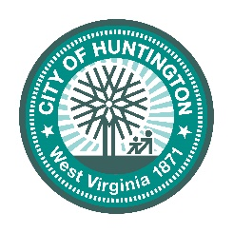

Agenda

Huntington Board of Zoning Appeals

Tuesday, August 18, 2026 - 5:30pm

- Call to Order

- Roll Call

- Approval of the July 2026 Minutes
- Approval of the July 2026 Orders
- BZA 26-12
- BZA 26-13
- BZA 26-14
- BZA 26-15
- BZA 26-16
5. New Petitions

BZA 26-11
Petitioner: Fairytale Bride Society, 1163 Jackson Ave., Huntington, WV 25704
Property Owner: Good Shepard Holiness Church, 1163 Jackson Ave., Huntington, WV 25704
Property Location: 1163 Jackson Ave., Huntington, WV 25704
Issue: A petition to request a conditional use to allow for a Redevelopment of a Closed Church in an R-4 Two-Family Residential District.

BZA 26-17
Petitioner: Daniel Eric Bryson, 2544 Hilton Ave., Ashland, KY 41102
Property Owner: Freddie L. Hayes, 54 County Rd. Unit 67, Scottown, OH 45678
Property Location: 105 7th Ave., Huntington, WV 25701
Issue: A petition to request a conditional use to allow for an Auto Service and Repair Station Shop in an I-1 Light Industrial/Commercial District.

BZA 26-18
Petitioner: Huntington School of Beauty Culture, 4110 U.S. Route 60, Huntington, WV 25705
Property Owner: RSD Holdings LLC, P.O Box 322, Barboursville, WV 25504
Property Location: 611 7th Ave., Huntington, WV 25701
Issue: A petition to request a conditional use to allow for a Trade School in an I-1 Light Industrial/Commercial District.

6. Announcements/Discussion

7. Adjournment

