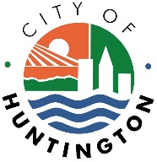

A G E N D A

HUNTINGTON CITY COUNCIL
May 26, 2020
7:30 p.m.

- Invocation and Pledge of Allegiance

- Roll Call

- Synopsis of Last Meeting

- Reports of the Mayor

- Resolution re: #2020-R-30 – A RESOLUTION OF COUNCIL AUTHORIZING PARTICIPATION IN THE CABELL-HUNTINGTON-WAYNE HOME CONSORTIUM FOR THE PERIOD OF jULY 1, 2020 TO JUNE 30, 2023

Sponsored by: Councilwoman Joyce Clark

- Resolution re: #2020-R-32 – A RESOLUTION OF COUNCIL CONFIRMING THE APPOINTMENT OF GAIL HENDERSON-STAPLES TO THE POSITION OF MUNICIPAL JUDGE FOR THE CITY OF HUNTINGTON

Sponsored by: (assigned pending committee approval)

- Good & Welfare

- Adjournment

